Function : block of code which performs specific task.. why do we create it? Reusability

DLL > : Multiple functions we can store here , Reusability & Share it

Web Service > Multiple functions we can store here , Reusability & Share it , but reachability is more . **Service available on web**

Whenever web comes , HTTP , SOAP protocol , and it sends data in XML form

We make notes ? functions

Share with friends : dll

Publish it : web service

using System;

using System.Collections.Generic;

using System.Linq;

using System.Web;

using System.Web.Services;

namespace ProductWebService

{

/// <summary>

/// Summary description for ProductService

/// </summary>

[WebService(Namespace = "http://tempuri.org/")]

[WebServiceBinding(ConformsTo = WsiProfiles.BasicProfile1_1)]

[System.ComponentModel.ToolboxItem(false)]

// To allow this Web Service to be called from script, using ASP.NET AJAX, uncomment the following line.

// [System.Web.Script.Services.ScriptService]

public class ProductService : System.Web.Services.WebService

{

[WebMethod]

public int add(int x, int y)

{

return x + y;

}

[WebMethod]

public int subtract(int x, int y)

{

return x - y;

}

[WebMethod]

public int product(int x, int y)

{

return x * y;

}

[WebMethod]

public int divide(int x, int y)

{

return x / y;

}

}

}

How to consume it

Right click > Add Service Reference > Advanced > Add Web Reference

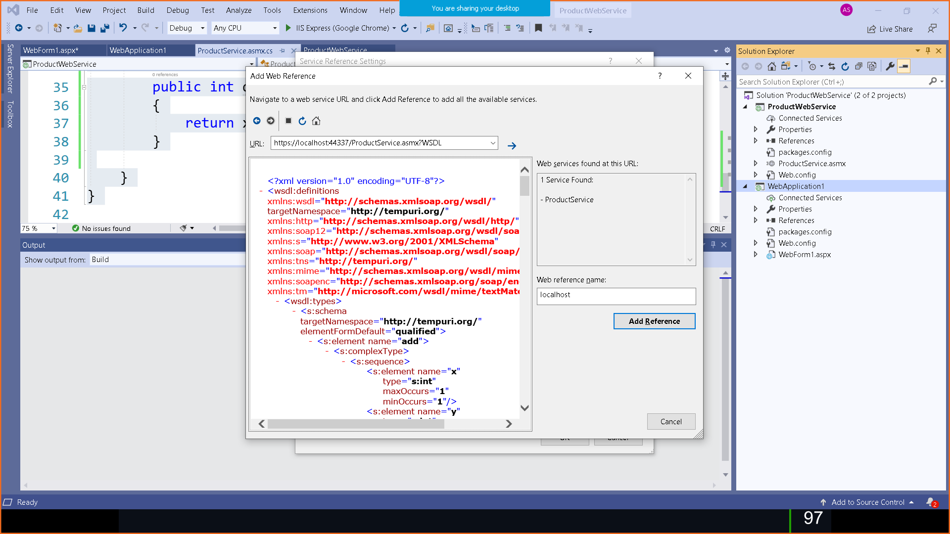

FOR ERROR LIKE THIS

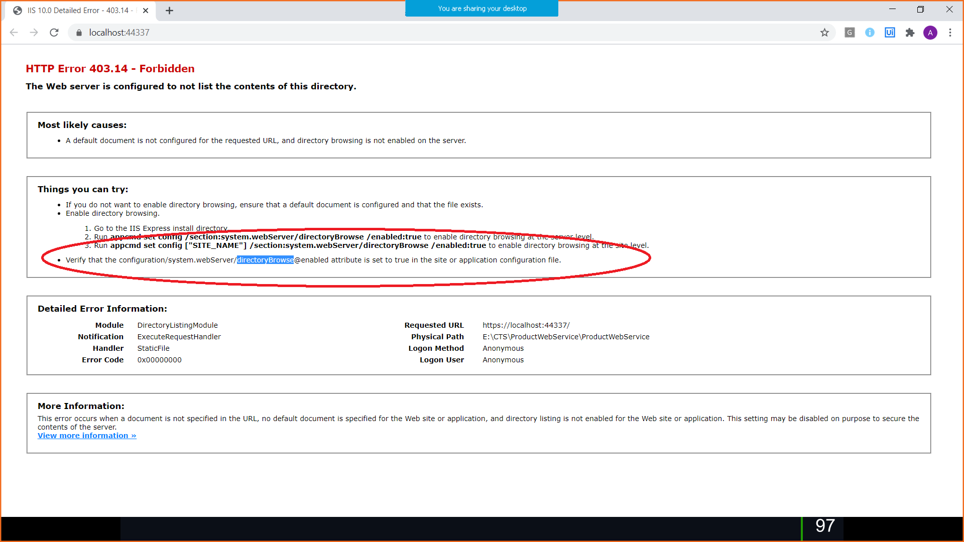

<system.webServer>

<directoryBrowse enabled="true"/>

</system.webServer>

using System;

using System.Collections.Generic;

using System.Linq;

using System.Web;

using System.Web.UI;

using System.Web.UI.WebControls;

namespace WebApplication1

{

public partial class WebForm1 : System.Web.UI.Page

{

protected void Page_Load(object sender, EventArgs e)

{

}

**protected void Button1_Click(object sender, EventArgs e)**

**{**

**localhost.ProductService productService = new localhost.ProductService();**

**TextBox3.Text = ( productService.add(Convert.ToByte(TextBox1.Text), Convert.ToByte(TextBox2.Text))).ToString();**

**}**

**protected void Button2_Click(object sender, EventArgs e)**

**{**

**localhost.ProductService productService = new localhost.ProductService();**

**TextBox3.Text = (productService.subtract(Convert.ToByte(TextBox1.Text), Convert.ToByte(TextBox2.Text))).ToString();**

**}**

**}**

}